8/16 Channel H.264 Multiplex DVR

Features:

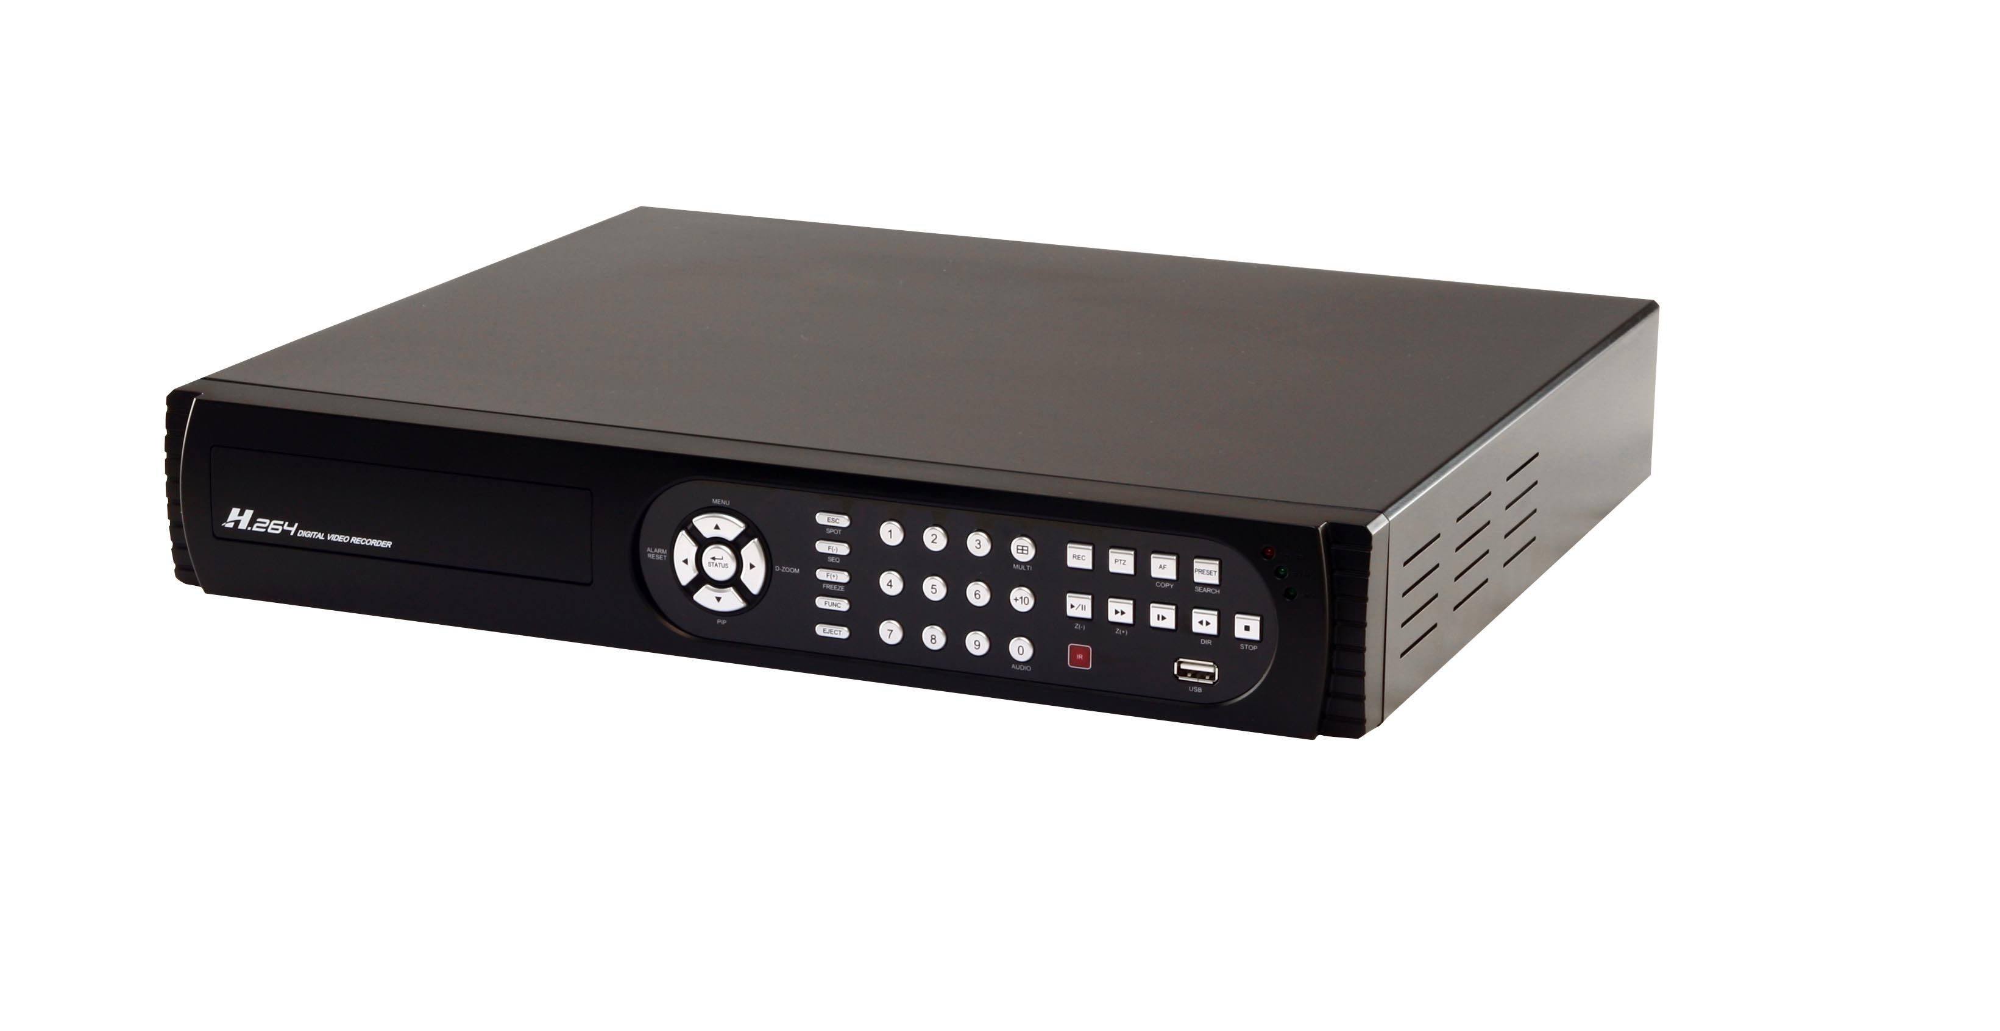
Advanced
■ 2 USB ports for mouse usage and backup.
■ Dual streaming enhances the speed of network transmission.
■ Built-in VGA output up to 1024x768 resolution.
- Individual setup of resolution, frame rate and video quality
for each channel.
■ Still image snapshot.
■ AVI converter with time stamp.

Basic
■ H.264 compression ideal for saving HDD space.
■ Real time live display.
■ Live display, record, backup, playback and network access simultaneously.
■ Picture-in-picture monitoring and 2X to 8X digital zoom display.
■ Control methods: front panel, USB mouse, IR remote controller, client viewer.
■ Intuitive GUI for easy configuration and menu driven operation.
■ Pan / Tilt / Zoom camera control.
■ Data backup: USB devices, network.
■ Event triggered with email notification: motion detection, alarm, video loss.
■ Supports Internet Explorer with same GUI as DVR site.
■ Multi-language OSD.
■ Central Management System (CMS) supports up to 15 DVRs.
■ 3G/GPRS mobile phone monitoring.

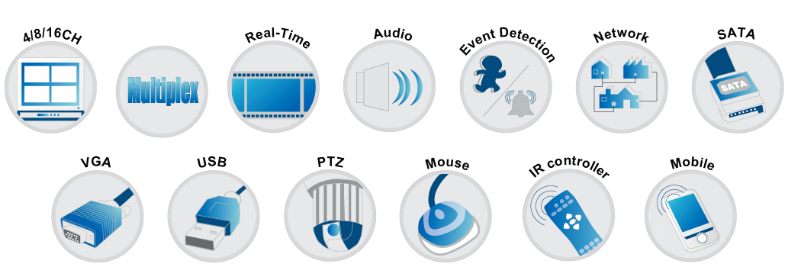

Specifications:
Model No. | D16-62CHV | D08-62CHV
Video System | NTSC / PAL switch
Video Input | 16 CH BNC | 8 CH BNC
Video Input Level | 1.0 Vp-p Composite, 75 Ohm Balanced
Video Output | 1 CH BNC
SPOT Output | 1 CH BNC
VGA Output | 1024x768
Audio Input | 4 CH RCA
Audio Input Level | 0.5~1.4 Vp-p @ 20K Ohm
Audio Output | 1CH RCA
Audio Backup | YES
Sensor | 16 input / 1 output | 8 input / 1 output
RS-485 | Pan / Tilt / Zoom camera
USB Port | 2 ports
Mouse | USB mouse
IR Remote Controller | YES
HDD Support | SATA HDD x 3 (Max. 1TB each)  or  SATA HDD x2 + DVD writer x1 | SATA HDD x2 (Max. 1TB each)  + DVD writer x1
DVD Writer | Optional
Display Division | 1,4,9,13,16 | 1,4,9
GUI | YES
Title | 14 characters
PIP | YES
Digital Zoom | 2X ~ 8X
Video Compression | H.264
Audio Compression | ADPCM
Resolution | 720x480, 720x240, 360x240 (NTSC)  720x576, 720x288, 360x288 (PAL)
Frame Rate | 120, 240, 480 (NTSC)  100, 200, 400 (PAL) | 60, 120, 240 (NTSC)  50, 100, 200 (PAL)
Quality | Highest, High, Normal, Basic, Below Basic
Record Mode | Manual, Schedule, Event (motion detection/sensor)
Pre-Alarm Recording | 16MB (10 sec)
Post-Alarm Recording | 1-999 sec
Motion Detection | 16X12 (sensitivity 1~15)
Search Mode | Time, Event
Playback Speed | Fast Forward/Backward 2X/4X/8X/16X/32X/64X  Slow Forward/Backward 1/2X,1/4X,1/8X,1/16X  Play/Pause
Backup Mode | USB flash driver / Network / Optional DVD media
Network Compression | H.264
Software | YES
Internet Explorer | YES
CMS | YES
3G Mobile Phone | Support
Network Users | 5
Remote Notification | Email message
Service | TCP/IP, SMTP, DHCP, DDNS, PPPoE
Daylight Saving | YES
Password | 5 users including 1 administrator  user authority selectable
Event List | 10000
Log List | 10000
Watchdog | Software Watchdog
Recovery | Auto-Reboot
Key Lock | YES
Firmware Update | USB device
Dimension | 430mm (W) x 70mm (H) x 360mm (D)
Power Source | DC12V
Operating Environment | 30 ~ 80% RH, 5°C ~ 40°C (41°F ~ 104°F)

